**WEEK-8**

**AIM:**

List the software requirements for the installation of Django.

**SOFTWARE REQUIRNMENTS:**

* **Install Python:**

1. To check if python installed on your machine, open command prompt and run following command
2. python --version
3. **OUTPUT**
   * If python is installed, Python 3.10.0 (version number may change)
   * If python is NOT installed, 'python' is not recognized as an internal or external command, operable program or batch file.

* **Install Django package:**

1. Open command prompt Run any one of the following commands
   * pip install Django OR
   * py -m pip install Django
2. You can tell Django is installed and which version by running the following command
   * python -m django –version

* **Install Visual Studio Code (VS Code)**

1. To check if VS Code installed on your machine, open command prompt and run following command
2. code --version
3. **OUTPUT**
   * If vscode is installed, 1.83.1 (version number may change)
   * If vscode is NOT installed, 'code' is not recognized as an internal or external command, operable program or batch file.

**WEEK-9**

**AIM:**

Creating a Django project on windows

**PROCEDURE:**

1. **Create workshop folder**:

Create a folder as C:/workshops/django/

1. **Open Command Prompt from the File Explorer :**

Type "cmd" into the address bar and press Enter to open the Command Prompt with the path of the current folder already set.

1. **Create a Django Project**:

Navigate to the directory where you want to create your Django project and run the following command to create a new project with the name "demo_project"

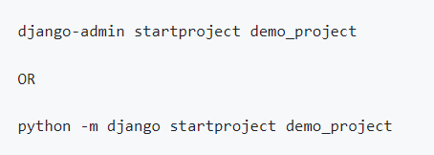

4.**Navigate to the Project Directory**:

Change your working directory to the newly created project folder



**5.Initialize the Database**:

Django uses a database to store information about your project. You'll need to create the database schema and tables by running the following commands:

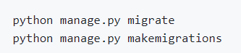

**5.Create a Superuser**:

You can create a superuser to access the Django admin interface for managing your application. Run the following command and follow the prompts to set user credentials (you can set user = admin and password = admin):

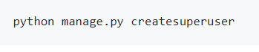

**6.Start the Development Server**:

To run your Django project locally, use the development server. Run the following command



**7.Access the application in browser**:

* <http://127.0.0.1:8000/> (change the port number if app is running on a different port)
* <http://127.0.0.1:8000/admin/> (change the port number if app is running on a different port). Log in with the superuser credentials to manage your application.

**OUTPUT:**

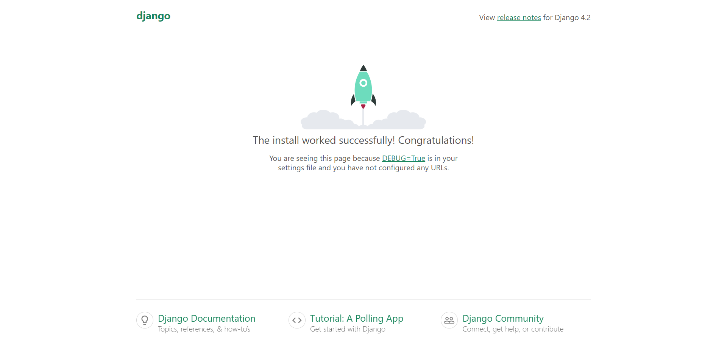

**Week-10**

**AIM:**

Create a Django app

**PROCEDURE:**

* 1. **Create app:**



Django creates a folder named members in my project, with this content

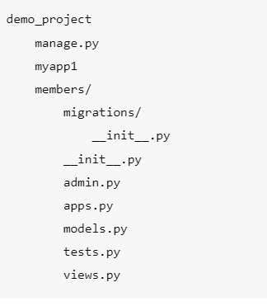

**2.Add/Update Views:**

* Go to myapp1/views.py

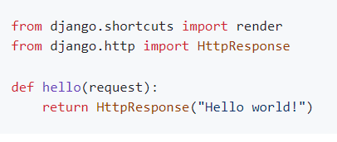

**3.Define URLs**

* Create a file (if not there already) named urls.py in the same folder as the views.py file in the app

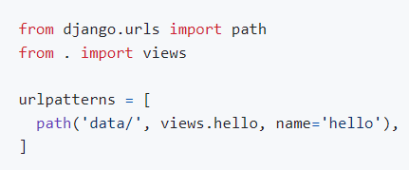

* The urls.py file you just created is specific for the app. We have to do some routing in the root project level as well.

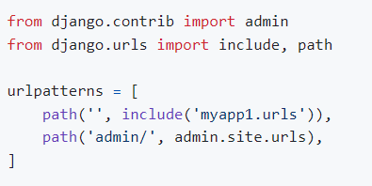

### 4.Run Server:

### 

### In the browser window, type 127.0.0.1:8000/data/ in the address bar.

### OUTPUT:

### 